**Meteorology Data**

**Instruction**

***Update, Nov 20***

The new Met_1_1.csv file includes the distance to the nearest meteorology station for each link and the ID for the station.

The new file, also includes the X, Y coordinates for center, end, and start of each link. This way I believe you can map the links. If you have access to ArcGIS I can send you the shape file.

* Look at the end of the file for X,Y coordinates, NEAR_FID, NEAR_DIST, NEAR_ANGLE.
* Use the Near_FID with the station ID below to match the meteorology data.
* The rest of variables on the file, are not useful for now.
* The Receptor_disatnce file, does have the pollution concertation for each receptor (CONC) along with the X and Y coordinates of the receptor. The NEAR_DIST shows the distance to the nearest road link.

***Base***

The meteorology data that is required for this research, can be obtained from meteorology stations. There exist 3 stations in the study area. So, I find the nearest stations to each road link. The data including daily values for over 5 years is included in two text file: the *.pfl and *.sfc file. The distance and angle to nearest Meteorology station for each link is calculated. Also, you can see the ID for the nearest station for each link, so you can match the data.

* 2 = NYC;
* 3= LAG;
* 4= JFK

**PFL Data**

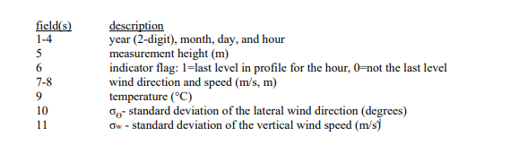

**SFC Data**

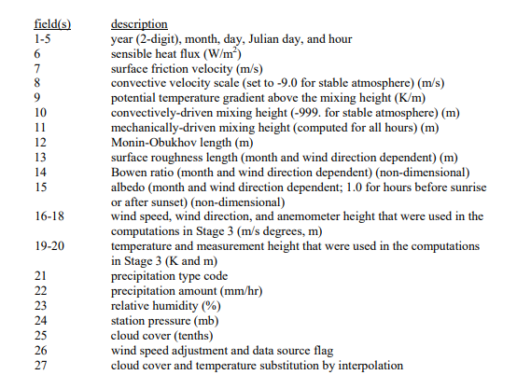

**Distance between a receptor and road link**

For the distance between road and receptors, I attached the dbf file that shows the distance between each receptor (meter) and angle to the nearest road.